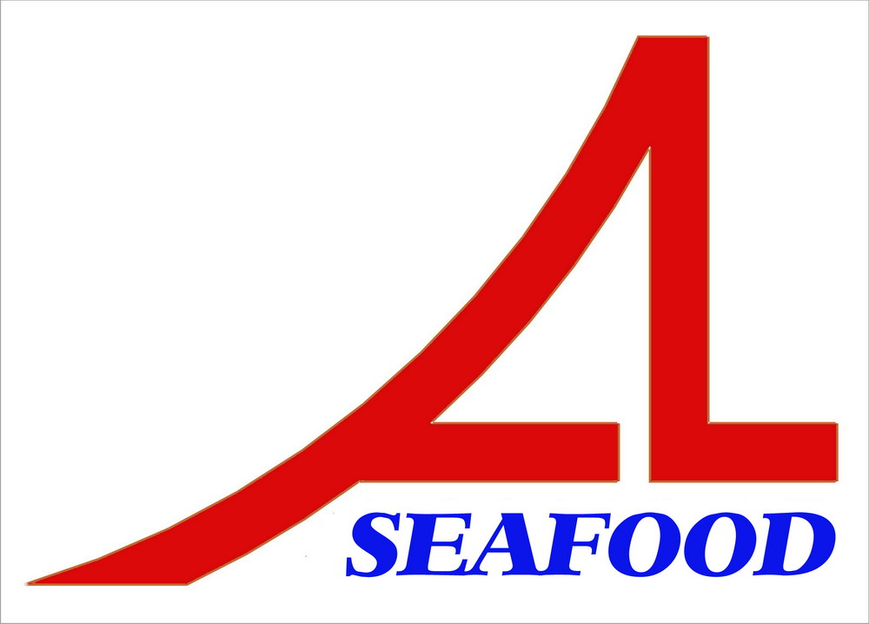AN LAC SEAFOOD CO.,LTD
LOT A14,4A STREET,HAISON INDUSTRIAL ZONE,DUC HOA DISTRICT,LONG AN PROVINCE,VIETNAM

AGREEMENT
Date : 25/03/2013
Party A : AN LAC SEAFOOD CO., LTD.

Address: Lot A14, 4A Street, Hai Son Industrial Zone, Duc Hoa District, Long An Province, Vietnam.

Tel/ Fax: 84-72-3850606 / 84-72-3850608
Represented by: Mr. NGUYEN THIEN DUY – Director

Party B : BIOVITAL COMPANY
Address: Ukraine, 49051 Dnepropetrovsk, ul. B.Khmelnitskogo 4
Tel.: 0038 0577322007 Fax: 0038 0675706385
Represented by: Nayalya V. Kryvenko – Director

After discussion , it is must be mutually agreed by both parties to sign for agreement as follow :
After comparing , two parties agree with the prepayment : 30.000 USD (base on the advice of bank No.: 130114-3 dated : 14/01/2013 ) will be paid to part contract No.: 78/03-TH.APPENDIX01 with amount 22.490 USD.
The agreement have valid from the date was signed .
The agreement is made into 02 (two) originals in English , each party keeps 01 (one) original with equal value .
PARTY A PARTY B


Nguyễn Thiện Duy Nayalya V. Kryvenko

